Bosworth Road Measham Swadlincote Derbyshire
DE12 7LQ
Telephone/Fax: 01530 270572
Email: swheatley@st-charles.leics.sch.uk
Head Teacher: Mrs F Knight

Dear Parents,

We have had a fantastic week in school. We have celebrated Roald Dahl Day, started a new Cooking Club and have elected our new House Captains and Vice Captains. A small group of Year 6 children were also excellent role models for our school at the Primary Ambassadors’ sports event at Whitwick and Coalville Leisure Centre on Wednesday.
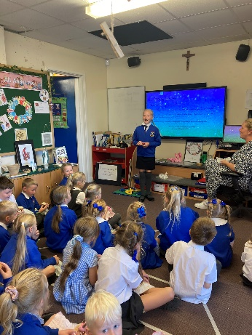
Parking:
Unfortunately, last week we had a near miss when children were crossing the school drive. Please can I ask for your cooperation and consideration when parking on Bosworth Road as no one should be parking on the yellow zig-zags or using the school drive for dropping children off for school (unless blue badge holders with permission from school to use the carpark). I have been in contact with Leicestershire County Council’s Traffic Enforcement team who should be visiting Bosworth Road in the near future – don’t say you haven’t been warned!

St Charles’ Staff are swimming the English Channel… in lengths!
To link to our Key Stage 2 topic ‘Mountains, Rivers, Coasts’ some of our school staff are going to swim the English Channel in lengths (1,352 lengths to be exact!) to help fundraise for a new shaded outside area for the children. Please follow the link below and support this great cause. Crowdfunding to help fund a new gazebo for our school playground on JustGiving

New St Charles’ Measham Instagram Page:
We have a new Instagram page! Please follow @stcharlesmeasham to see all of our latest updates. Don’t forget to get your friends, family and any prospective parents to follow us too.

Attendance:
Last week Class 1 achieved the highest attendance with 99.1%. Well done to all of our children that have been to school everyday so far this half term – keep it up.

Friends of St Charles (FOSC):
Thank you to everyone who attended the Annual General Meeting last night. During the meeting we planned forthcoming events and discussed the vital roles needed to keep our PTA running. Minutes of the meeting will be emailed to you all shortly.
Please see the dates of our forthcoming FOSC events at the end of this newsletter.
-2-

Trust Prayer for Her Majesty Queen Elizabeth II
Heavenly Father, we thank you for the immense blessing of our Queen. We thank you for her service and her wonderful example. We ask you to welcome her to her heavenly home and to reward the immense faith she always had in you. We pray for her family; be with them in their pain and their loss. May they feel your tender compassion. We pray for our world; may those in power reflect some qualities and values shown by Queen Elizabeth, never forgetting their responsibilities as servants of the communities they lead. Amen.

As instructed by the Department of Education we will be closed on Monday 19th September.

I wish you all a lovely weekend with your families.

Mrs Knight
Head Teacher
16th September 2022

Date: | Event:
30th September | Open Morning with the World’s Biggest Coffee Morning – details to follow.
6th October | Parents Evening
11th October | Parents Evening
14th October | Break up for half term
24th, 25th + 26th October | Yr5/6 PGL Residential
25th October | Friends of St Charles PTA meeting at 7pm at the Halfway House.
27th October | Spooky Disco 3:15pm – 4:15pm
3rd November | FOSC Bonfire Extravaganza from 5pm. Fireworks at 6pm.
10th November | Individual photos
2nd December | Menphys Carol Concert for children in the school choir
8th December | FOSC Christmas Fayre

