DERIC is a range of reading skills based on the 2016 reading content domains found in the National Curriculum Test Framework documents for KS1 and KS2.
DERIC is an acronym to aid the recall of the 5 reading skills as part of the UK’s reading curriculum. They are the key areas which we feel children need to know and understand in order to improve their comprehension of texts.
Children’s reading skills are taught and practised using DERIC during whole class reading sessions. We use DERIC as a method of ensuring that teachers ask, and students are familiar with, a range of questions.
- Decode: Word Reading
- Explain: Discussing vocabulary in context and discussing understanding of whole texts
- Retrieve: Finding Information in the text
- Interpret: Inference skills with an emphasis on using evidence
- Choice: Focus on author’s choice of words and layout
They allow the teacher to track the type of questions asked and the children’s responses to these which allows for targeted questioning afterwards .
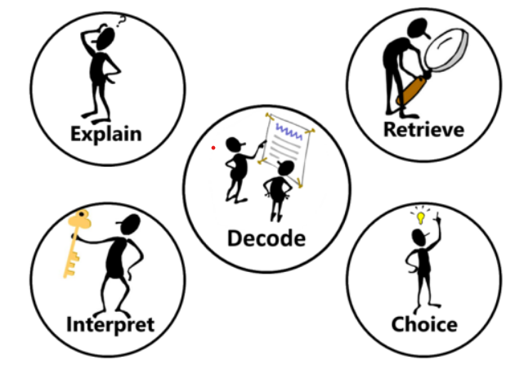

These skills in Reading Comprehension are taught in whole class reading lessons, using the chosen class texts. (See Whole Class Reading Plan). Lessons enable the children to share opinions about themes in the story and to understand more complex language patterns. Once these discussions have taken place, children learn a range of skills to enable them to answer questions about a text. The children are taught the skills of simple information retrieval and shown how to gain a deeper understanding of the text using the complex skill of inference.
Each class has planned novels which they study for one or two terms.
The ultimate aim is for children to become avid readers who are not only able to understand a text, but are able to make judgements and express opinions and preferences – clearly justifying their reasons.

 | Reception | Year 1 | Year 2 | Year 3 | Year 4 | Year 5 | Year 6
Decode  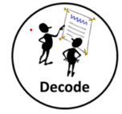  Word reading, segmenting and blending, fluency, confidence, checking sense, re-reading | ELG:  To use phonic knowledge to decode regular words and read them aloud accurately | Apply phonic knowledge to decode words accurately (for all 40+ phonemes) | Continue to apply phonic knowledge and skills, embedding automatic decoding.  Read accurately by blending sounds. Sound out unfamiliar words accurately | Use developing understanding about root words, prefixes and suffixes to read aloud with increasing fluency and understanding Break words down into syllables to decode unknown words quickly | Use knowledge of root words, prefixes and suffixes to read aloud with increasing fluency, understanding and expression. | Often applies their knowledge of root words, prefixes and suffixes to read fluently and understand the meaning of new words | Use root words, prefixes and suffixes to read aloud and to understand the meaning of new words.
 |  | Read words with 1+ syllable  Read words with apostrophes | Read most words with 2+ syllables | Uses a range of punctuation (at the end of the sentence and commas within) | Break words into different sized chunks, including syllables, to decode unknown word | Breaks long polysyllabic words with speed and reads across entire words | Break long polysyllabic words into syllables with speed and read across the entire word
 |  | Read common exception | Read common exception words  words and note any unusual correspondence between spelling and sound . | Read a wider range of common exception/ tricky words | Read a wider range of common exception/ tricky words and can see what makes them tricky. | Reads fluently with intonation, expression, appropriate pace and use of pauses to entertain and maintain interest | Reads fluently with intonation and expression, pauses, pace and emphasis to interest and entertain
 |  | Re-read books to build up fluency and confidence in word reading | In GPC matched books and age appropriate books) check a familiar book makes sense, correcting any inaccuracies | Notices mistakes they make in their reading using meaning, language structures and visual information and make corrections accurately | Notices mistakes they make in their reading and corrects them because the text does not make sense | Tries to notice mistakes in higher level texts and sometimes corrects them because the text does not make sense. | Notices mistakes in higher level texts and sometimes corrects them because the text does not make sense  Read longer complex sentences using commas, brackets, semi-colons, colons and dashes to accurately help them and others to understand
Explain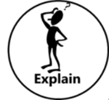  Discussing vocabulary in context; extending vocabulary, understanding of vocabulary and whole texts (including summarising) | ELG:  Offer explanations for why things might happen  Participate in small group, class and one-to-one discussions. | Able to explain clearly what they understand when someone reads to them | Explain what has happened so far in what he/she has read | Checking that the text makes sense to them, discussing their understanding and explaining the meaning of words in context | Checking that the text makes sense to them, discussing their understanding and explaining the meaning of words in context | Maintain positive attitudes to reading and understanding of what he/she reads by making comparisons within a book | Explain and discuss understanding of what he/she has read, including through formal presentations and debates, maintaining a focus on the topic and using notes where necessary
 | Use recently introduced vocabulary.  Making use of recently introduced vocabulary from stories, non-fiction, rhymes and poems when appropriate; - | Able to talk about word meanings and link new meanings to these. | Discuss and clarifying the meanings of words, linking new meanings to known vocabulary | Understand what he/she reads independently by checking that the text makes sense to him/her, discussing his/her understanding of words. | Maintain positive attitudes to reading and understanding of what he/she reads by using dictionaries to check the meaning of words that he/she has read | Understand what he/she reads by checking that the book makes sense to him/her, discussing his/her understanding and exploring the meaning of words in context. | Understand what he/she reads by identifying how language, structure and presentation contribute to meaning.
 |  |  |  |  | Maintain positive attitudes to reading and understanding of what he/she reads by discussing words and phrases that capture the reader's interest and imagination
 | ELG:  Make comments about what they have heard and ask questions to clarify their understanding.  Retelling stories and narratives using their own words and recently introduced vocabulary | Able to retell what they have read in sequence | Discussing the sequence of events in books and how items of information are related | Understand what he/she reads independently by identifying main ideas drawn from within one paragraph and summarise these | Understand what he/she reads independently by identifying main ideas drawn from more than one paragraph and summarise these | Summarise main ideas from more than one paragraph, identifying key details which support these. | Understand what he/she reads by summarising the main ideas drawn from more than one paragraph, identifying key details that support the main ideas and using quotations for illustration
Retrieve  Finding information in the text, skimming, scanning, re-telling, sequencing | ELG: Listen attentively and respond to what they hear with relevant questions, comments and actions. | Able to understand what they read. | Asking and answering questions | Understand what he/she reads independently by asking questions to improve his/her understanding of a text | Retrieve and record information from non-fiction over a wide range of subjects | Understand what he/she reads by asking questions to improve his/her understanding of complex texts | Ask questions to improve their understanding
 |  |  |  | Retrieve and record information from non-fiction | Understand what he/she reads independently by asking questions to improve his/her understanding of text with increasing complexity | Retrieve, record and present information from non-fiction
Interpret  Inference skills with an emphasis on using evidence, including prediction | Demonstrate understanding of what has been read to them. | Able to make inferences on the basis of what is being done | Make inferences on the basis of what is being said and done. | Understand what he/she reads independently by drawing inferences such as inferring characters' feelings, thoughts and motives from their actions, and justifying inferences with evidence | Understand what he/she reads independently by drawing inferences such as inferring characters' feelings, thoughts and motives from their actions, and justifying inferences with evidence clearly taken from the text | Understand what he/she reads by drawing inferences such as inferring characters' feelings, thoughts and motives from their actions, and justifying inferences with evidence | Draw inferences such as inferring characters’ feelings, thoughts and motives from their actions, and justifying inferences with evidence
 | Anticipate – where appropriate – key events in stories; | Beginning to link what they read or hear read to their own experiences | Make plausible predictions about what might happen on the basis of what has been read so far | Understand what he/she reads independently by predicting what might happen from details stated | Understand what he/she reads independently by predicting what might happen from details stated and implied | Understand what he/she reads in increasingly complex texts by predicting what might happen from details stated and implied | Predict what might happen from details stated and implied
Choice  Author choice of words and layout |  |  | Understand and recognize simple recurring literary language in stories and poetry. | Understand what he/she reads independently by identifying how language, structure, and presentation contribute to meaning to include paragraphs, headings, sub-headings, inverted commas to punctuate speech. | Understand what he/she reads independently by checking that the text makes sense to him/her, discussing his/her understanding and explaining the meaning of words in context. | Discuss and evaluate how authors use language, including figurative language, considering the impact on the reader. | Discuss and evaluate how authors use language, including figurative language, considering the impact on the reader.
 |  |  |  | Identifying how language, structure, and presentation contribute to meaning
