St Charles Catholic Primary School
Marking and Feedback Policy

This Policy was adopted by The Governing Body of St Charles Catholic Primary School on:
Date: | Signed by:
It will be reviewed on: |  | Date: September 2023

Mission Statement
“Let all that you do be done in Love.
Love is made possible with respect.” St Charles Borromeo
At St Charles’ we pray, love and learn together as one school family, with Christ at our centre. We create and experience joy every day in our home, our school and our parish.
Vision
Children will leave St. Charles’:
- With a love for learning.
- With Christ in their hearts.
- With outstanding manners.
- Showing care and respect for all.
- Having achieved their best.
- With a sense of pride and confidence.
- With a deep sense of responsibility.
- With life-long skills to enhance their future.
Values:
Everyone at St. Charles’ will be:
- Compassionate
- Aspirational
- Determined
- Enthusiastic
- Humble
- Friendly
- Trustworthy

“The most powerful single moderator that enhances achievement is feedback. “

Introduction
Marking and feedback is an important and valued part of ‘Assessment for Learning’ and used as a tool to improve teaching and learning. At St Charles, we believe in focussing on the positive achievements children make and this belief is reflected in our policy. Feedback clearly refers to a whole range of responses including:
- written
- oral
- feedback from self, peer, TA’s and teachers

Aims:
- Give feedback that focuses on positive achievements
- Give feedback that reflects the learning outcomes and success criteria
- Use feedback as a tool to improve teaching and learning
- Use feedback to motivate and encourage learners
- Involve children through peer and self-assessment
- Allow time to read feedback and make improvements

Feedback
Feedback is delivered through three key practices:
Self-marking is pupil-led and enables and rapidly enables them to identify correct and incorrect responses. Learning is sometimes but not always moved forward with this approach, as it only allows identification of what is correct and what is not. This approach is used regularly in maths, reading and in flashback four quizzes.

Verbal feedback prioritises moving learning forward in the moment. Teachers and support staff hold effective discussions with individuals, groups and/or the whole class, explaining how learning can be improved by providing nest steps. This practice is expected to take place in every subject.

Whole class feedback prioritises moving learning forward either at the end of the session or at the beginning of the next session. Whole class feedback has a positive impact on learning, in addition to developing pupils’ individual, group and whole class character. At St Charles’ we use a one-page format to record their feedback which is always shared with pupils at the beginning of the next session in the teaching sequence. This enables a review of prior learning, retrieval of previously taught knowledge and enable pupils to move their learning forward by responding to the feedback provided where required.

Early Years
In the early years, whole class feedback is provided by the class teacher and/or support staff as appropriate to the learning that is taking place. By the summer term, whole class feedback will be provided at least once per day.

Key Stage One
In Key Stage One, whole class feedback is provided by the class teacher and/or support staff in some lessons, appropriate to the learning that is taking place. In English, Maths and RE, whole class feedback forms are completed for some lessons each week.

Key Stage Two
In Key Stage Two, whole class feedback is provided by the class teacher and/or support staff in many lessons, appropriate to the learning that is taking place. In English, Maths and RE, whole class feedback forms are completed for most lessons each week.

Impact
Whole class feedback enables timely feedback for pupils to deepen their learning, enable further understanding, secure knowledge in the long-term memory and build their schema. At its best, it supports the review of learning, retrieval of knowledge, deepening of vocabulary, development of character and feeds into the schools assessment practices.

Marking
Marking will still continue to be used, where appropriate, for some lessons. In these instances teachers may use:

- Pink highlighting where work is exceptional, and exceeds the success criteria
- Blue highlighting where improvements could be made
- In maths ticks for correct calculations; dots to be used for incorrect calculations

Teachers will recognise and identify whether children have met the learning objective in each lesson:
LO | Learning Objective met
LO ^ | Learning Objective partially met
LO o | Learning Objective not met
* | Gap Task follows (optional)

Feedback expectations:

English | Teachers will use discretion on when to complete whole class feedback sheets. However it would be expected that this would be completed twice per week for English, on average.  Teachers will tick work to acknowledge it has been looked at when appropriate.  Lessons may begin with a review after whole class feedback has been shared.
Maths | Children complete a pre and post unit assessment to demonstrate the learning they acquire throughout each maths unit.  Lessons often begin with a review (Flashback 4) to revise prior content.  Teachers will live mark during maths lessons for immediate feedback and so corrections can be identified and addressed.  Marking will be a mixture of self, peer and teacher marked.  Calculations may be self marked using green pens – correct answers are ticked, incorrect answers are crossed.
RE | Children complete a pre and post unit assessment to demonstrate the learning they acquire throughout each topic.  Pupils complete 6 pieces of work per topic, two of which are extended writing opportunities, and relate to the RE driver words.  Teachers will use their discretion on when to complete the whole class feedback sheet, however it would be expected that 2 sheets are completed for each topic.  Teachers may tick other work to acknowledge it has been read.  Key religious words which are spelt incorrectly will be identified and practised through whole class feedback.
History / Geography | At the beginning of each topic children will complete a blank knowledge organiser quiz to demonstrate their knowledge in this area.  Low stakes quizzes and multiple choice questions will be used as retrieval practice throughout the topic.  Throwback 4’s will be used to revisit learning and key knowledge from prior topics in history and geography.
Science | Children complete a pre and post unit assessment (blank knowledge organiser quiz) to demonstrate the learning they acquire throughout each topic. Lessons include a ‘step for depth’ gap task to push children’s learning forward.

Presentation Guidelines

Although the content of a pupils work is most important, we should also have high expectations for presentation.

New Page
A new page should be started for every new piece of work

Date
Every new piece of work must be dated as follows;

- Long date for English, RE and Topic work
- Short date for Maths

Title
The key skill/objective/I can statement / Learning focus should form the title of the piece of work.

Handwriting
We should encourage children to write in a neat cursive style as soon as they are ready, handwriting practise should be planned for.
Ensure that children begin writing at the margin.

MATHS:
Use a pencil for drawing and maths work

Review Feedback – Whole class teacher feedback books

Teachers will complete whole class feedback overviews for writing tasks and RE. Teachers will write in their teacher feedback book rather than writing individual comments in each pupil’s book. This ensures that feedback is timely and purposeful and reduces teacher workload. This will then enable teachers to plan a feedback session and adapt the next lesson.

Teachers use the following template below to make notes based on children’s learning in the lesson.
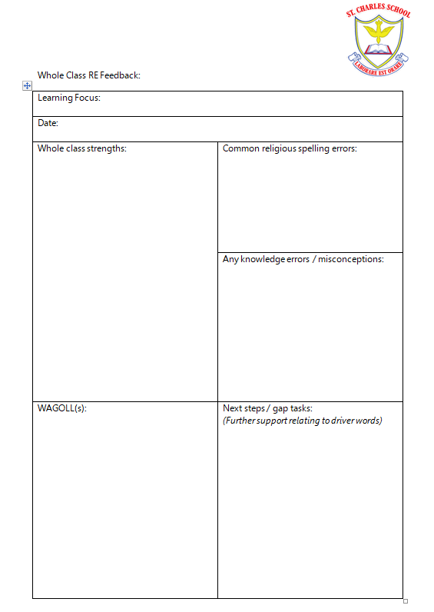

This information will be used to:
- Identify common misconceptions
- Identify work to praise and share
- Identify any children who require further intervention or further challenge
- Identify any main errors including spelling errors
- Inform subsequent planning and delivery sessions

Peer marking and editing is completed in green pen. At the start of a session a teacher may share the whole class feedback with the class as a starting point for the session.

Feedback sessions

Teachers will use the notes in their whole class feedback books to provide feedback to their class. This may be whole class, group or individual feedback and may include the following features:

- Share feedback with individuals
- Share feedback with groups
- Share feedback with whole class
- Share good work / wagolls (What a good one looks like), picking out effective features
- Common / basic errors may be shared or retaught if necessary

Monitoring
This policy will be reviewed annually. Feedback will be monitored termly by the Senior Leadership Team and Subject Leaders. Teacher Feedback Books will be reviewed during subject Book Looks and be referred to in Pupil Progress Meetings. The Book Looks will form part of the annual monitoring cycle for impact of effective responsive teaching strategies.

