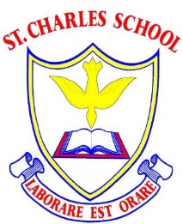

Implementations of Science Lessons at St Charles:
What would we expect to see in a Science lesson in our school?
- Children working on objectives in line with the curriculum intent for Science (as published on the school website).
- Knowledge Organiser stuck at the front of each new unit.
- Cold Knowledge Organiser Quiz at the beginning of each unit followed by a warm Knowledge Organiser Quiz at the end.
- Children share their ‘wonders’ for the Topic at the beginning.
- Current lesson is placed within sequence of learning within the unit.
- Each lesson begins with a short ‘prior knowledge’ question
- Flashback (4 Questions that cover content from previous units of work ) To be completed at least once every half term.
- Topic-specific vocabulary are clearly explained and revisited within the correct context during the lesson. My Turn, Your Turn method to be used to teach new vocabulary.
- Teaching of science will take the form of some direct instruction.
- Children will be taught substantive scientific knowledge (content) first, before they undertake enquiry.
- Children will be taught disciplinary knowledge (scientific enquiry skills - ‘how was the knowledge established?’) relevant to their key stage.
- Tasks directly relate to the learning intentions. All children are working towards meeting the same learning intentions. They are supported and/or challenged appropriately.
- Talk task and plenaries - regular review of children's understanding through discussions, questioning and quizzes.
- Quizzes and assessment tasks are used at the beginning and end of topics.

An outline of a St Charles Science Class Reading Lesson:
- Prior Learning
- Vocabulary focus: introduction of new vocabulary that will be used in the lesson.
- Teaching input
- Talk Task – retrieval and understanding.
- Task – All children working towards the same learning intentions (substantive and disciplinary knowledge)
- Depth for Learning Question – Reasoning and understanding.

