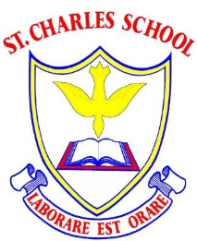

Implementations of History Lessons at St Charles:
What would we expect to see in a History lesson in our school?
- Children working on objectives in line with the National Curriculum on a Topic led theme with a key focus, such as ‘Nurturing Nurses’, ‘Walter Tull’, ‘WWII’ or ‘The Victorians’.
- Key Stage 2 Topics are planned on a 4-year running cycle and years alternate to focus predominately on British or Worldwide history. This means we can make links from year to year about what Britain was doing during other periods of time.
- Key Stage 1 Topics are planned on a 2-year running cycle
- In Key Stage 2, every History Topic is chronological. We aim to start with one ancient topic, then medieval and then modern-day History Topic each year. From this we can then develop the children’s understanding of chronology and eras in history.
- Teachers plan from an overview sheet for each Topic which outlines the National Curriculum objectives and Chris Quigley Key Skills for each Milestone 1-3.
- Teachers work in Key Stage teams to create a Knowledge Organiser and key questions for each week of learning. Teachers then create their own medium-term plans from this framework.
- On our History Knowledge Organisers, where appropriate we will include an Elsewhere and Meanwhile box- explaining to the children what was happening in England or Worldwide during that time.
- Each learning objective is linked to a Driver Word- these are used for both geography and history lessons: Describe, Compare, Communicate, Investigate and Interpret, Locate and Chronology.
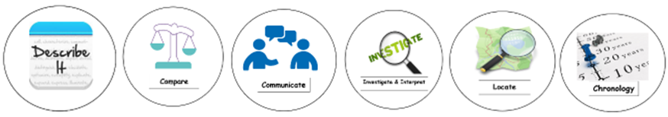
- For each learning objective, there is a History link to a key area which is known as Making Links. These ensure that we are planning for a range of areas of History when we cover a Topic. For History, these are:
Location | Chronology | Daily life  - Homes  - Rich and poor
Religion and culture | Significant figures | Impact on modern day

- On the medium term plans, there are creative write opportunities planned in which are linked to their History learning such as a fact file, recount of events, diary entry, etc.
- At the start of every Topic you will see an assessment of prior learning from a ‘blank’ knowledge organiser or in the form of a quiz for KS1.
- You will see Throwback 4 in books which is a small series of questions that review learning from other Topics they have done in previous years. This is to ensure previous knowledge is retained and reviewed often.
- Children may use their historical enquiry skills to use images or real-life artefacts with no other information to investigate and interpret what it was for, asking the ‘5 W’s’ What? Who? When? How? Why?
- After historical enquiry sessions, children then discovering what it was that they explored and learning more about them
- Encouraging children to ask questions about what it was like, what daily life was like, etc
- Children may compare and contrast people in society, monarchs, etc
- Children may learn about a significant figure
- Children will use timelines
- Children will understand that there may be different accounts of historical events and understand what propaganda is
- Children will link learning to the impact of our modern day, such as changes in monarchy, religion and culture, beliefs, inventions, etc.
- Historical vocabulary is used regularly in discussion and written work
- Mini Knowledge Organiser tasks and quizzes are completed to constantly review key vocabulary and facts for that Topic
- High quality written work linked to the subject, including cross-curricular writing
- You will see a class timeline where we pin-point eras/ events/ people studied on our timelines and add to it as the year goes by, referring to it regularly.
- On display a ‘What is History?’ poster
- Assessments of History Knowledge organiser at the end
An outline of a St Charles History Topic:
- Knowledge Organiser prior learning harvest
- Subject learning (i.e. a study in history, significant figures, era, etc )
- Prior learning of the current topic being revisited in the form of quizzes.
- Throwback 4 quizzes which revisit learning from previous Topics in previous year groups so knowledge is retained/revisited.
- Knowledge organiser assessment at the end of each topic.

