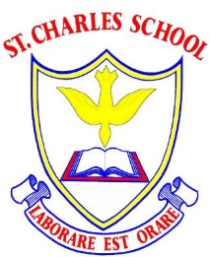
Implementations of Music Lessons at
St Charles:
What would we expect to see in a Music lesson in our school?
- Children working on objectives in line with the National Curriculum.
- Lesson is based on units planned in the long term plan and is within a sequence following the current medium term/unit plan.
- Each unit will have a cross-curricular focus and a musical focus (e.g. exploring beat).
- Musical vocabulary will be reviewed and introduced in each lesson.
- A short warm up will be used at the start of each lesson (usually involving singing and actions).
- Listening, creating, composing and performing music will all happen throughout a unit.
- Students will be introduced to a wide variety of instruments from different countries, cultures and time periods.
- Students will be shown a variety of notation to demonstrate changing pitch and rhythm, leading to stave notation eventually.
- Students will work in groups to perform different elements of a piece, leading to a whole group ensemble.
- Some performances might be dances focused on learning the rhythm of a piece of music.

An outline of a St Charles Mathematics Lesson:
- Warm up
- Listening, responding to and evaluating a piece of music
- Vocabulary focus
- Practising/performing a related piece using instruments and voice
