Equality and Diversity at St Charles
Class 1 | 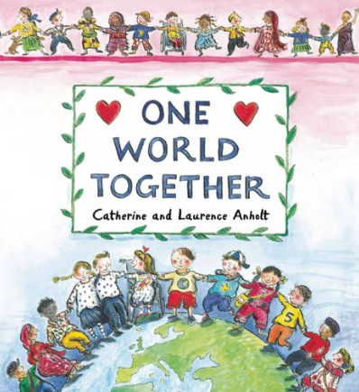 | 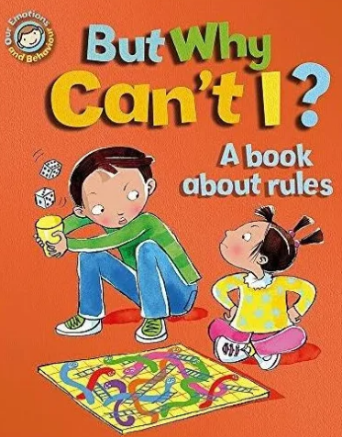 | 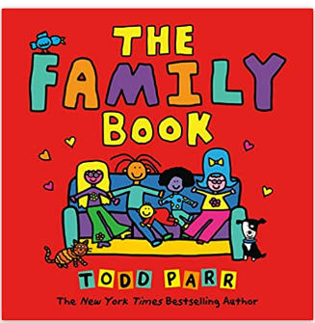 | 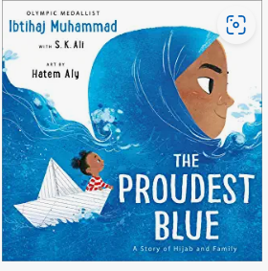
 | To understand that we shared the world with different people | To understand why rules are important | To understand that all families are different | New experiences. Intolerance and resilience- being proud of who you are.
Class 2 | 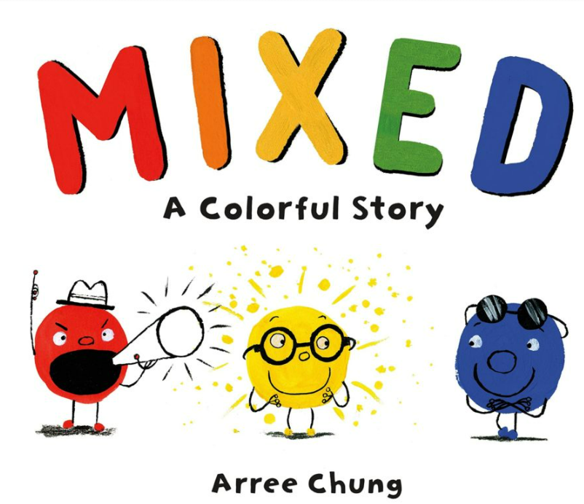 | 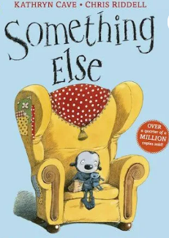 | 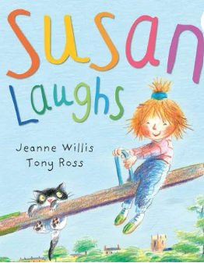 | 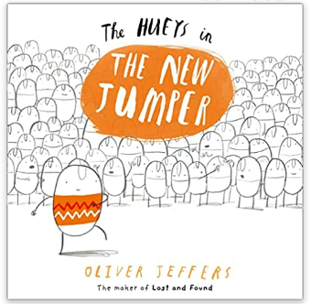
 | Colour, tolerance, embracing differences | Belonging, tolerance, celebrating differences | Disabilities, we are all the same | Being different and unique is a good thing
Class 3 |  | 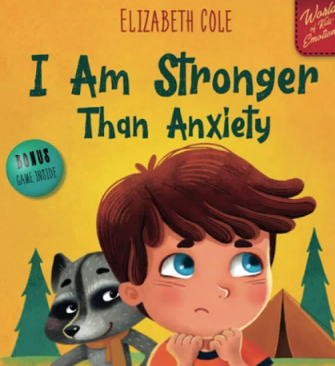 | 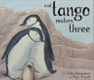 | 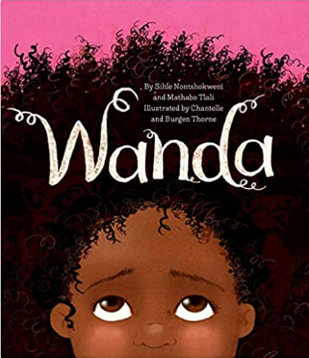
 | To know when to be assertive: that its OK to like different thing | How to recognise and deal with the emotion of anxiety | To accept people who are different from me.  Families come in many different forms | Identity and beauty, celebrating how cultural pride is learned and passed on over generations.
Class 4 | 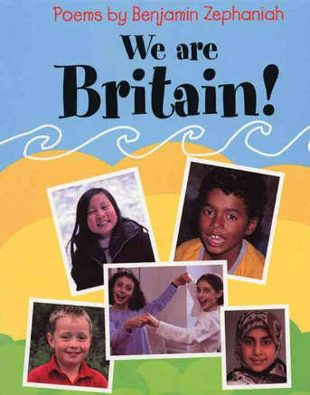 | 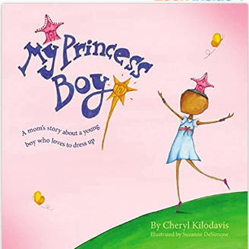 | 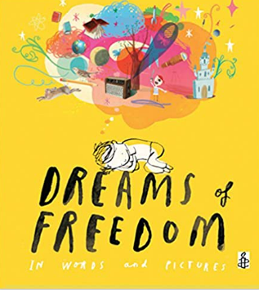 | 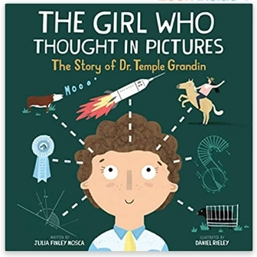
 | We live in a wonderful varied and Diverse society | This is a story about unconditional love and acceptance. It is also a call for tolerance and an end to bullying and judgments. | To recognise my freedom.  Rights | Challenges the stereotype that being disabled doesn’t bring any benefits with it
Class 5 | 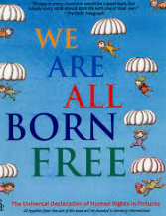 | 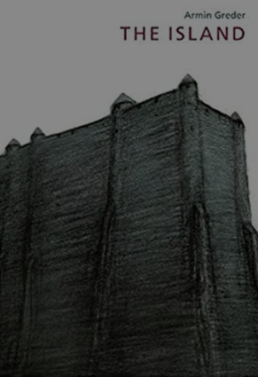 | 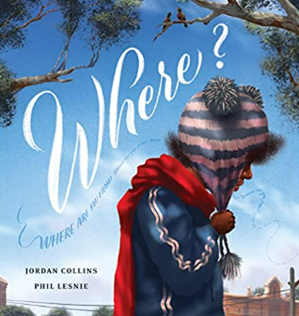 | 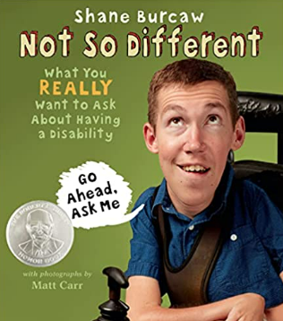
 | Wherever we live, whoever we are, we are protected by the Universal Declaration of Human Rights | To challenge the causes of racism | How we treat each other, how we feel about injustice and microaggressions and how we are all equal in the universe. | Living life with a disability.

The belief in the unique dignity of the human person made in the image and likeness of God underpins the approach to all education in a Catholic school. Our approach to Personal Development therefore is rooted in the Catholic Church’s teaching of the human person and presented in a positive framework of Christian ideals. The themes of diversity and equality are taught within a carefully planned and sequenced curriculum in all year groups (see attached Personal Development Curriculum Overview) within the units on 'British Values' and 'Living in the Wider World'.
As a school we use the 'Ten : Ten' programme to deliver the statutory requirements of RSE and PSHE covering a broad range of topics which ensure coverage of the National Curriculum and suggested Personal development areas from Ofsted. In addition our curriculum includes non-statutory units that have been chosen for their identified relevance for our children. (Economic well-being - aspirations , work and careers; Economic well-being- money).
The Personal Development Curriculum includes planned and sequenced opportunities for the children to learn about:
British Values
Equality (Protected Characteristics)
Health and well-being (Healthy bodies and healthy minds)
Living in the Wider World
Economic Well-being: Aspirations, work and careers
Economic Well-being: Money
Careers and Aspirations
The Personal Development Curriculum is at least as well planned as the other curriculum areas, and is given equal importance across the school. It includes an overview to ensure coverage and carefully planned progression. Medium Term plans identify clear learning objectives and Knowledge goals for each lesson. See attached Curriculum Overview for Personal Development and example of Medium Term planning
A robust PSHE policy is in place, after consultation with parents / carers (see attached); PSHE lessons occur weekly with the class teacher and specific RSE is taught in year groups once a year in a 'Well-being week'. Parents have been consulted on the content and specific vocabulary or our RSE provision, and are again informed of the content prior to the 'Well-being' week (letter attached). All teaching staff have received training.
Whole School Values and themes embed all that we do at St Charles through the 'St Charles Way'. Common themes across the school include care, respect, responsibility, and the British Values of individual liberty, tolerance, democracy, mutual respect and the rule of law. These values underpin all that we do at St Charles. In addition they are visited through the year in planned whole school assemblies weekly.
As a school ,we take positive action to deal with disadvantages affecting a pupil or pupils because of a protected characteristic. Resources in our Curriculum are carefully planned to ensure they represent a wide diversity. For example, books chosen for our 'Whole Class Reading' have been chosen for their diversity in their main characters, settings and contexts (including a variety of family settings). We have begun a collection of picture books which include different examples of the protected characteristics, and of British Values.
We work to ensure that our children understand that:
Everyone is different; we celebrate our differences; we are all equal in our differences.
The Equalities Act became law in 2010. It covers everyone ibn Britain and protects people from discrimination, harassment and victimisation. Everyone in Britain is protected. This is because the Equality Act protects people against discrimination because of the protected characteristics that we all have.
Under the Equality Act, there are nine protected Characteristics:
Age; gender reassignment; race; religion or belief; marriage or civil partnership; sex; sexual orientation; pregnancy and maternity.

