Dear Parents and Carers

This year the government has introduced a new curriculum for Relationship, Sex and Health Education, commonly shortened to RSHE which is compulsory for schools.

Please see our revised draft policy for Relationships and Sex Education. It is based on the model policy given to schools by the Catholic Education Service and authorised for use in Catholic Schools by the Catholic Bishops of England and Wales.

We would like your views on this document before it becomes school policy. Please answer the questions below and leave a comment if you wish.
Thank you for your help in this.

In your opinion:
- Is the draft policy clear and easy to understand?
- Is the draft policy appropriate for pupils of primary age?
- Does the draft policy reflect the teaching and traditions of the Catholic Church?
You can email your opinions and suggestions to the school office: office@st-charles.leics.sch.uk , return the suggestions slip or speak to a member of staff by phoning the school.
Yours faithfully,
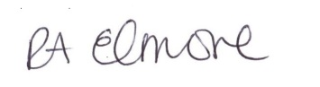
Mrs Elmore
---------------------------------------------------------------------------------------------
I would like to make the following comment or suggestion:
________________________________________________________________________________________________________________________________________________________________________________________________________________________________________________________________________________________________________________________________________________________________________

